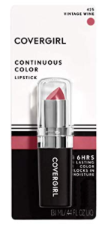
Competition/Performance attire:
DON’T Forget Your Costumes & Shoes
Costume Common Senses:
-Always have a second pair of tights available.
-Place costumes in a garment bag for travel.
-Carry hats in a hatbox or container to prevent them from damage.
-Hang and press costumes before each performance.
-Place your name in all costumes and shoes.

-No Nail Polish, No outside Jewelry, No fake nails.
-No Underwear (Nude under garments with no lines OK)
-Clear bra straps and backs only.
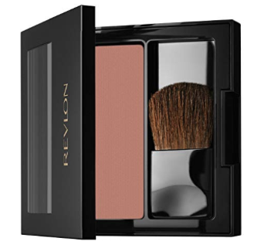
-“Under all”: Tan leotard clear straps can be worn as underwear.
-No eating or colored drinks in costume
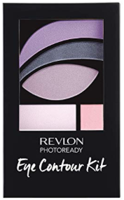
Makeup: All make up needs to match.

-COVERGIRL Continuous Color Lipstick, Vintage Wine
-Revlon powder blush: Bronze Beauty
-Revlon 520 watercolors

L’Oreal Paris 205 Petite Pearl
For under brow bone.
(any white eye shadow will do!)

Other things dancers need:
-Foundation: should be littler warmer/tanner/ bronzer than skin tone. Not Matching
-Eyeliner
-Mascara or Fake eyelashes with Eyelash glue (Duo)
-Setting spray or powder
-Diamond earrings with rhinestone rim. 10mm
*Portable mirror

Hair needs to be slicked back for performances unless otherwise noted.
-Gel
-Hairspray
-Bobby pins
-Donut bun (if needed)
-Ponytail elastics
-Tiny rubber elastics (Clear please if needed).

Stepping Up Dance Center apparel needs to be worn at competition & Convention venues. This helps us pick you out from a crowd. Jackets can be ordered for 80$. Not mandatory
While dressed as a Stepping Up Dancer you represent us. Please act appropriately.

